SUSTAINABILITY
Since the early 1990s, sustainability has become an increasing priority for facilities projects. It is no secret that building construction and operation have an enormous direct and indirect impact on the environment in terms of energy use, atmospheric emissions, use of raw materials, waste generation, water use, and many other factors. As economy and population continue to expand, the design, construction and operation community will face increasing challenges to meet the new demands for facilities that are accessible, secure, healthy, and productive while minimizing their impact on the environment.
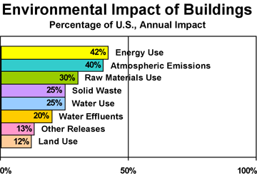
Figure 1. Source: Levin, H. (1997) Systematic Evaluation and Assessment of Building Environmental Performance (SEABEP), paper for presentation to "Buildings and Environment", Paris, 9-12 June, 1997.
For the design, construction and operation of a facility, there is an especially important interface between the indoor and outdoor environments, that of the building envelope. The building envelope is comprised of the outer elements of a building—foundations, walls, roof, windows, doors and floors. The prime functions of the building envelope are to provide shelter, security, solar and thermal control, moisture control, indoor air quality control, access to daylight, and views to outside, fire resistance, acoustics, cost effectiveness and aesthetics. Because of the varied and sometimes competing functions associated with the building envelope, an integrated, synergistic approach considering all phases of the facility life cycle is warranted. This "sustainable" approach supports an increased commitment to environmental stewardship and conservation, and results in an optimal balance of cost, environmental, societal, and human benefits while meeting the mission and function of the intended facility.
DESCRIPTION
The main objectives of sustainable design are to avoid resource depletion of energy, water, and raw materials; prevent environmental degradation caused by facilities and their infrastructure throughout their life cycle; and create built environments that are accessible, secure, healthy, and productive.
While the definition of what constitutes sustainable building design, construction and operation is constantly evolving, there are six fundamental principles that nearly everyone agrees on.
- Optimize Site Potential—Creating sustainable buildings starts with proper site selection, and the location, orientation, and landscaping of a building affect the local ecosystems, transportation methods and energy use.
- Minimize Energy Consumption—A sustainable building should rely on efficiency and passive design measures rather than fossil fuels for its operation. It should meet or exceed applicable energy performance standards.
- Protect and Conserve Water—In many parts of the country, fresh water is becoming an increasingly scarce resource. A sustainable building seeks to reduce, control, and/or treat site runoff, use water efficiently, and reuse or recycle water for on-site use when feasible.
- Use Environmentally Preferred Products—A sustainable building should be constructed of materials that minimized life-cycle environmental impacts such as global warming, resource depletion, and human toxicity. In a material context, life cycle raw materials acquisition, product manufacturing, packaging, transportation, installation, use, and reuse/recycling/disposal.
- Enhance Indoor Environmental Quality (IEQ)—The indoor environmental quality of a building has a significant impact on occupant health, comfort, and productivity. Among other attributes a sustainable building should maximize daylighting, provide appropriate ventilation and moisture control, and avoid the use of materials that are high in VOC emissions.
- Optimize Operational and Maintenance Practices—Incorporating operating and maintenance considerations in to the design of a facility will greatly contribute to improved work environments, higher productivity, and reduced energy and resource costs. Designers are encouraged to specify materials and systems that simplify and reduce maintenance requirements; require less water, energy, and toxic chemicals and cleaners to maintain; and are cost-effective and reduce life-cycle costs.
FUNDAMENTALS
Following are sustainability recommendations pertaining to the design and construction of the building envelope.
Optimize Site Potential
- Consider Climatic Conditions—consideration of the local climatic conditions (temperature, moisture, wind) can influence the materials of construction of the building envelop, the amount of and performance of glazing used specific to each orientation, and the overall energy performance of the building.
- Reduce Urban Heat Islands—the design of the horizontal elements (roof) of the building envelope should consider the impact on the site's urban heat island. Finish the facility's roof with light colored materials to reduce energy loads and extend the life of the roof, especially in warmer climates. Consider incorporating vegetated roof materials. Use a roofing product that meets or exceeds Energy Star Standards.
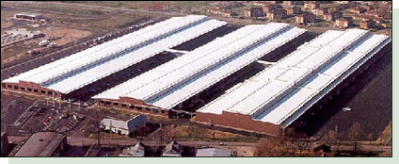
Figure 2. Energy Star® Roof-compliant, high-reflectance, and high emissivity roofing can lower roof surface temperature by up to 100°F, decreasing the amount of heat transferred into a building.
Minimize Energy Consumption
- Consider Climate Conditions—building envelope components should be responsive and appropriate for the climate of the building.
- Reduce Urban Heat Islands—use light colored finish materials or vegetated components as part of the roof.
- Optimize Thermal Insulation—optimize the insulation performance of the envelope opaque elements for both heating and cooling seasons.
- Incorporate High Performance, Spectrally Selective Glazing—the orientation, amount and performance of vertical and horizontal glazing should be appropriate for the climate of the building. Carefully analyze the thermal (U-factor), solar (solar heat gain factor–SHGF) and daylighting (visible transmittance–VT) performance of glazing on each elevation of the building. The performance criteria will vary depending upon orientation and dominant strategy (e.g. solar performance or daylighting performance).
- Employ Effective Solar Shading Devices—use exterior shading devices such as overhangs, vertical fins and lightshelves as energy efficiency measures (with consideration of maintenance and security/safety issues).
- Integrate Photovoltaic Panels—incorporate Building Integrated Photovoltaic (BIPV) panels as part of the building envelope system or solar shading system as a way of generating on-site, renewable energy.
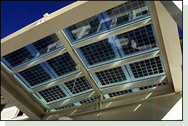 | Figure 3. A PV skylight entryway  (Courtesy of DOE/NREL)
- Analyze Envelope Performance With Energy Simulation—use energy simulation and life cycle analysis tools to optimize the performance of all components of the building envelope. Make informed decisions about the components of the building envelope based on life cycle performance.
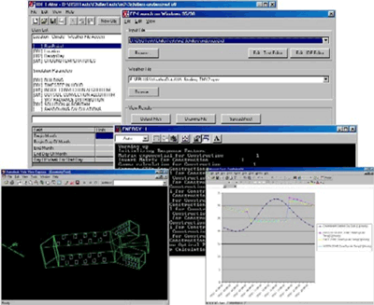
Figure 4. Energy Plus Screen Captures
(Courtesy DOE)
- Commission Envelope Elements—the building commissioning process should include commissioning of the building envelope to insure that all performance requirements are being met. Commissioning of the building envelope can identify areas of concern related to air infiltration and leakage, moisture diffusion, surface condensation, and rain water entry—all issues that can negatively impact the building's energy performance and indoor environmental quality. Of particular importance is to begin commissioning of the building envelope during design when design modifications can be easily incorporated, rather than waiting until construction when remediation can cost significantly more.
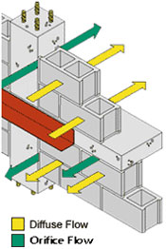 | Figure 5. Air Leakage through a Building Enclosure
While the LEED® Green Building Rating System requires buildings to undergo Fundamental Building Commissioning of systems to achieve certification, it merely recommends that some form of building envelope commissioning be incorporated. Lemieux and Totten have proposed a Building Envelope Commissioning process that could supplement the Fundamental Building Commissioning required for LEED® certification.
Protect and Conserve Water
- Stormwater Management—use a vegetated roof as a means of capturing, filtering and reusing rain water on site. Captured rainwater on the roof or façade can also be collected, filtered/treated, and then reused on-site for landscape irrigation or toilet flushing, or held and released after a delay to municipal stormwater systems.
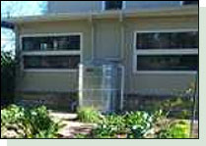 | Figure 6. Rainwater harvesting for landscape irrigation use  (Courtesy of Texas Water Development Board)
Use Environmentally Preferred Products
- Evaluate Environmental Preferability Using LCA—employ life cycle assessment (LCA) tools like ATHENA® and BEES to evaluate environmental performance of building envelope components or products. Embodied energy (energy required to acquire, manufacture, transport, assemble, install) should be minimized where possible. Eliminate the use of materials that pollute or are toxic during their manufacture, use or reuse (VOCs, lead, asbestos, PCBs, CFC or HCFC blowing agents for insulation materials). Where possible, evaluate and consider the use of building envelope assemblies that can be easily "de-constructed" at the end of their useful lives.
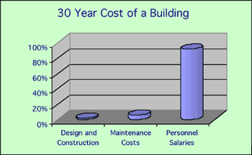
Figure 7. Viewed over a 30 year period, initial building costs account for approximately just 2% of the total, while operations and maintenance costs equal 6%, and personnel costs equal 92%.
Source: Sustainable Building Technical Manual
- Maximize Recycled Content—where possible, incorporate recycled content in building envelope construction materials, especially post-consumer recycled content.
- Use Wood from Sustainably Managed Forests—when using wood products as part of the building envelope, ensure they are supplied from forests that are certified for their sustainable management practices.
Enhance Indoor Environmental Quality
- Value Aesthetic Decisions—windows should be provided that afford building occupants views outside but do not negatively impact the visual comfort of the work environment.
- Provide Thermal Comfort—components of the building envelope should adequately address issues of thermal comfort at the building perimeter, particularly thermal and solar performance of glazing systems. ASHRAE Standard 55—Thermal Environmental Conditions for Human Occupancy should be used as the basis for thermal comfort analysis.
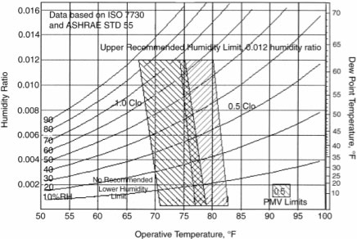
Figure 8. Courtesy ASHRAE Standard 55-2004, Thermal Environmental Conditions for Human Occupancy.
- Maintain Appropriate Indoor Air Quality—design and construction of the building envelope should give appropriate consideration to the moisture dynamics so that water is not transmitted through the building envelope in to the building construction such that indoor air quality is compromised. Where appropriate, consider the use of operable windows for natural ventilation and occupant control, but be careful to consider the effect on the building HVAC system so as not to negatively impact the building's overall energy performance. Use dedicated/separate outside air and conditioned air distribution systems for the building perimeter zones to maintain positive pressurization at the building envelope and appropriate indoor air quality for occupants in the perimeter zones.
- Avoid Use of Materials High in Pollutants—limit the use of volatile organic compounds (VOCs) in such products as paints and coatings, and sealants and adhesives.
- Create a High Performance Luminous Environment—design the glazing systems to maximize the use of daylight. Make sure that the electric lighting is controlled to respond to daylight levels to maintain a consistent light level on the work surface in the perimeter spaces. Use internal shades or blinds for glare control (not for control of solar gain) to maintain a healthy visual environment.
Optimize Operational and Maintenance Practices
- Preventative Maintenance—building occupants and operators should be appropriately trained in a comprehensive preventative maintenance program to keep all building systems associated with the building envelope functioning as designed.
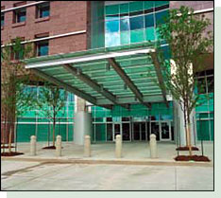 | Figure 9. The architectural entries of the EPA Kansas City Regional Office are designed to prevent undesirable air particles from entering the building. Originally conceived as a permanent grating "walk-off system," an easier to maintain stone floor with walk-off carpets was eventually utilized offering lower capital and operational costs.  (Courtesy of GSA and Koll Construction.)
- Environmentally Preferred Cleaning Products—institute a policy for the purchase and use of resource-efficient and non-toxic cleaning products, supplies and procedures for building envelope elements.
APPLICATIONS
The benefits of high performance, sustainable design, construction and operation are universal. All different types of buildings, including office buildings, schools, hospitals, libraries, courthouses, and research facilities, can and should incorporate sustainable and high performance strategies and systems that consider the entire building life cycle, above and beyond just the elements associated with the building envelope.
EMERGING ISSUES
Balancing Security/Safety and Sustainability Objectives—Providing for sustainable designs that meet all facility requirements is often a challenge to the building design, construction and operation community. With limited resources it is not always feasible to provide for the most secure facility, the most architecturally expressive design, or energy efficient building envelope. From the concept stage through the development of construction documents, it is important that all project or design stakeholders work cooperatively to ensure a balanced design. Successful designs must consider all competing design objectives.
Integrated Design—Designers are moving away from the conventional building design approach that has historically resulted in little interaction between all parties involved in the project. There is a movement to embrace integrated building design, fostering communication amongst all parties that could be involved in the project, and facilitating working together from the start to coordinate and optimize the design of the site and the building.
RELEVANT CODES AND STANDARDS
Executive Order 13148, "Greening the Government through Leadership in Environmental Management"
Executive Order 13123, "Greening the Government through Efficient Energy Management"
Executive Order 13101, "Greening the Government through Waste Prevention, Recycling, and Federal Acquisition"
ADDITIONAL RESOURCES
Publications
e design Online—The journal of the Florida Design Initiative
Environmental Building News
Environmental Design & Construction Magazine
Field Guide for Sustainable Construction by the Pentagon Renovation and Construction Program Office, Department of Defense. 2004.
Green Buildings—Guidelines for Creating High-Performance Green Buildings by Pennsylvania Department of Environmental Protection. 1999.
Greening Federal Facilities Guide by U.S. Department of Energy. 2001.
High Performance Building Guidelines by New York City Department of Design and Construction. April 1999.
Minnesota Sustainable Design Guide by Regents of the University of Minnesota, Twin Cities Campus, College of Architecture and Landscape Architecture.
Sustainable Building Technical Manual by U.S. Department of Energy and U.S. Environmental Protection Agency. 1996.
Sustainable Facilities Guide by U.S. Air Force
Sustainable Federal Facilities - A Guide to Integrating Value Engineering, Life-Cycle Costing, and Sustainable Development by Federal Facilities Council, Washington DC, National Academy Press, 2001.
Organizations
Sustainable Buildings Industry Council (SBIC)
U.S. Green Building Council (USGBC)
Others
DOE Office of Energy Efficiency and Renewable Energy (EERE) Building Technologies Program
DOE Office of Energy Efficiency and Renewable Energy (EERE) High Performance Buildings
Federal Energy Management Program (FEMP), U.S. Department of Energy
GreenBuilder Green Building Program, City of Austin, TX
Green Building Advisor
Green Buildings, U.S. Environmental Protection Agency
Greener Buildings—An informative site created as a partnership of GreenBiz.com and the U.S. Green Building Council.
High Performance Buildings Database U.S. Department of Energy
Leadership in Energy and Environmental Design (LEED®) Green Building Rating System, U.S. Green Building Council
Smart Communities Network—Green Buildings, U.S. Department of Energy
Sustainable Design and Development Resource website, U.S. Army, ERDC-CERL
WBDG
Design Objectives
Sustainable Branch

